1. **Pointer Swap Function**

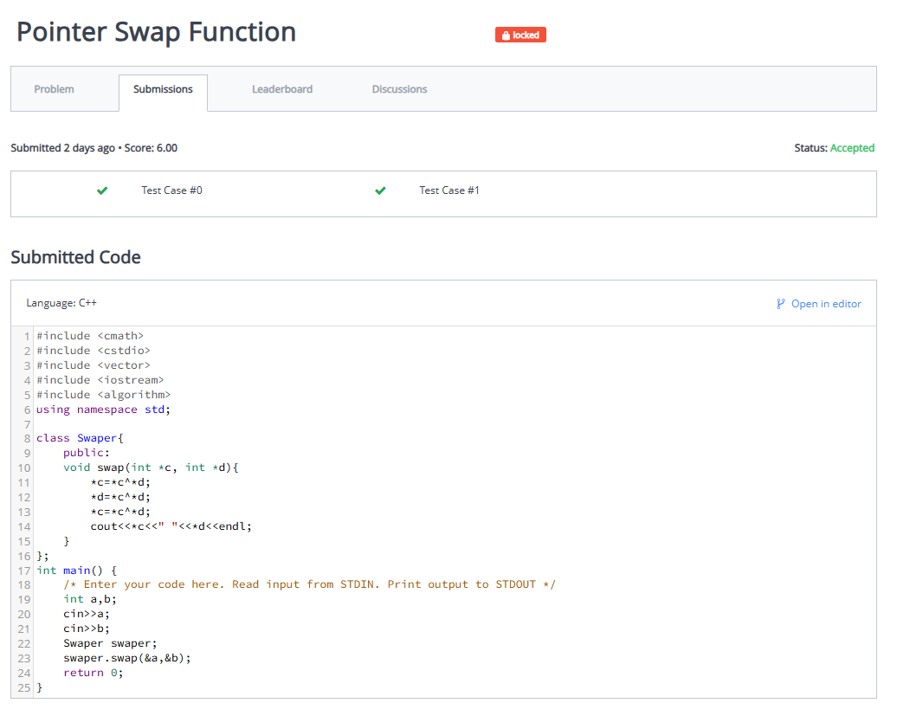

1. **Find Duplicate Elements using Pointers**

1. **Sum of Elements in 2D Array using Pointers**

1. **Transaction Rollback System**

1. **Dynamic Memory Cleanup using Destructor**

